Moreno, Melissa

March 10, 2019

SUR5386

Tutorial 5 – Georeferencing using ENVI

Step 1.2-



Step 1.3-



Step 2.1-

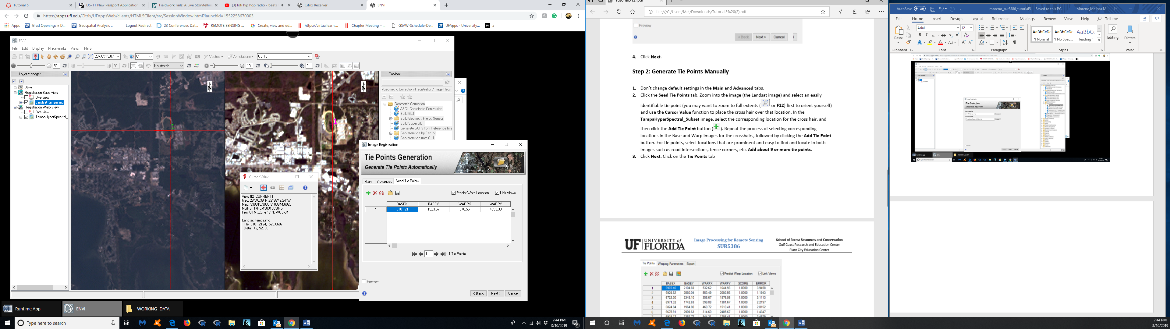

Step 2.3-

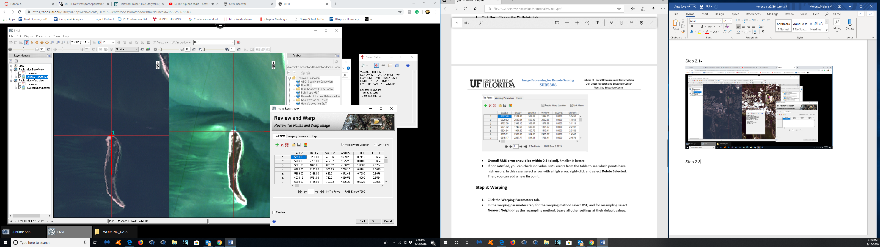

Step 3.2-

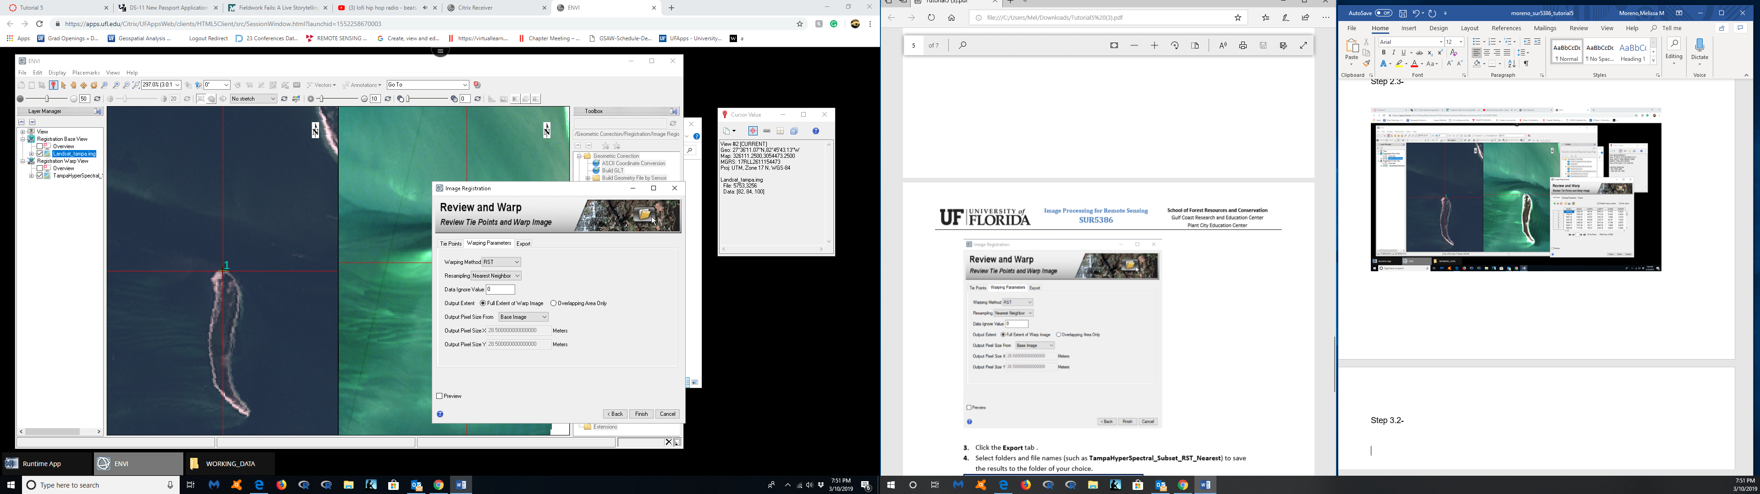

Step 3.3-

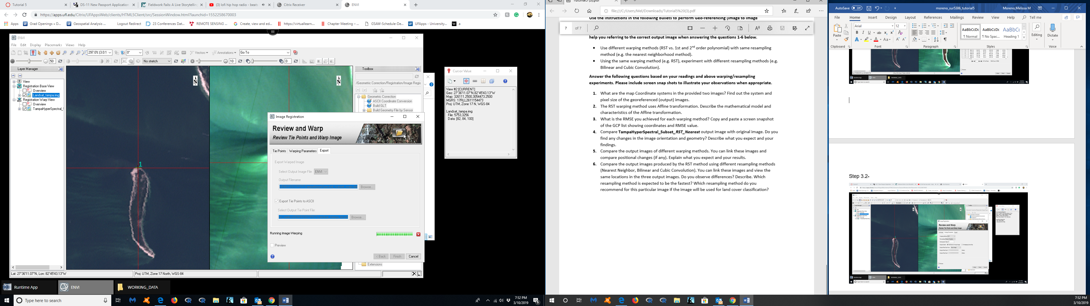

Assignment

1. What are the map Coordinate systems in the provided two images? Find out the system and pixel size of the georeferenced (output) images.

Landsat_tampa.img-

Pixel X and Y= 28.5

Coordinate system= UTM_Zone_17n

Geogcs- GCS_WGS_1984

TampHyperSpectral_Subset

Pixel X= 28.98

Pixel Y= 29.99

Coordinate system= UTM_Zone_17n

Geogcs- GCS_WGS_1984

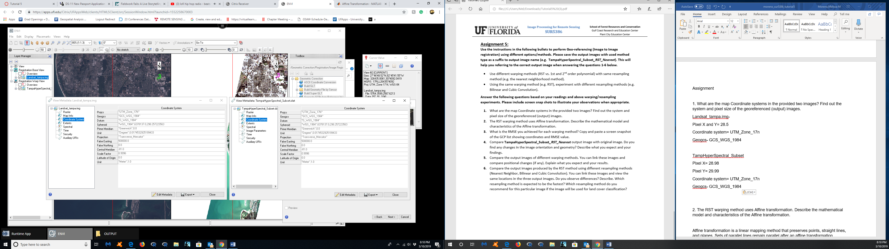

2. The RST warping method uses Affine transformation. Describe the mathematical model and characteristics of the Affine transformation.

Affine transformation is a linear mapping method that preserves points, straight lines, and planes. Sets of parallel lines remain parallel after an affine transformation.

The affine transformation technique is typically used to correct for geometric distortions or deformations that occur with non-ideal camera angles. For example, satellite imagery uses affine transformations to correct for wide angle lens distortion, panorama stitching, and image registration. Transforming and fusing the images to a large, flat coordinate system is desirable to eliminate distortion. This enables easier interactions and calculations that don’t require accounting for image distortion. (<https://www.mathworks.com/discovery/affine-transformation.html>)

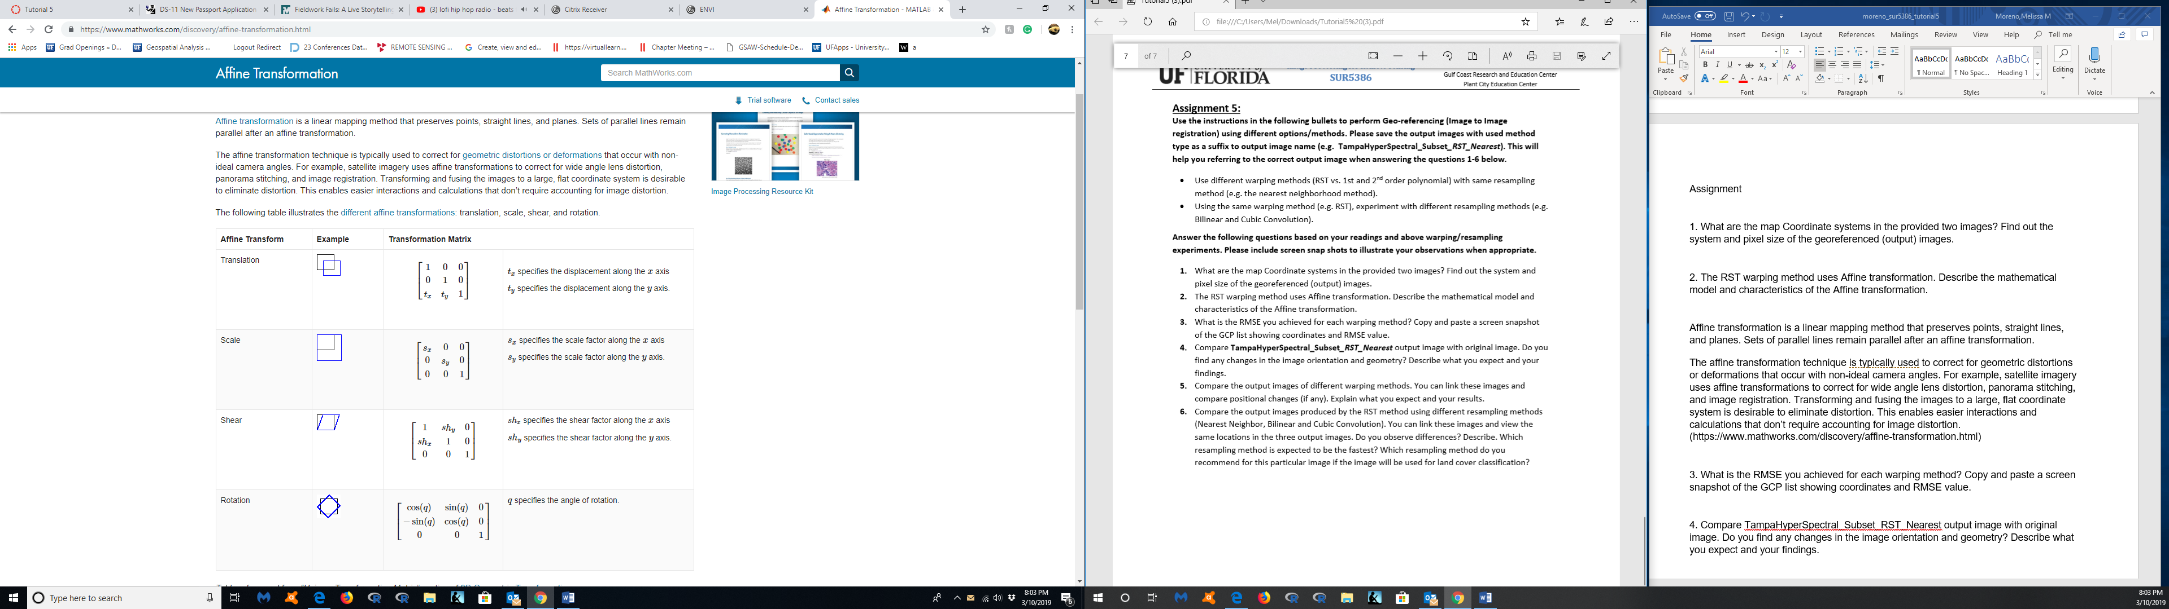

RST: Rotation, scaling, and translation; this is the simplest method. To perform RST warping, you need three or more GCPs. The RST warping algorithm uses an affine transformation:

x = a1 + a2X + a3Y

y = b1 + b2X + b3Y

This algorithm does not allow for shearing in the image warp. To allow for shearing, use a first-order polynomial warp. While the RST method is very fast, in most cases, you can achieve more accurate results with a first-order polynomial warp.

Polynomial: Polynomial warping is available from the 1st to nth degree. The degree available is dependent upon the number of GCPs selected where #GCPs > (degree + 1)2.

A first-order polynomial warp includes an XY interaction term to account for image shear:

x = a1 + a2X + a3Y + a4XY

y = b1 + b2X + b3Y + b4XY

Triangulation: Delaunay triangulation warping fits triangles to the irregularly spaced GCPs and interpolates values to the output grid. This is the default option.

Depending on the Method you chose, set the following method-specific options:

For polynomial warping, enter the desired polynomial Degree. The degree available is dependent on the number of GCPs defined where #GCPs > (degree + 1)2.

(https://www.harrisgeospatial.com/docs/WarpingResampling.html)

3. What is the RMSE you achieved for each warping method? Copy and paste a screen snapshot of the GCP list showing coordinates and RMSE value.

RST

RMS ERROR: 1.6539

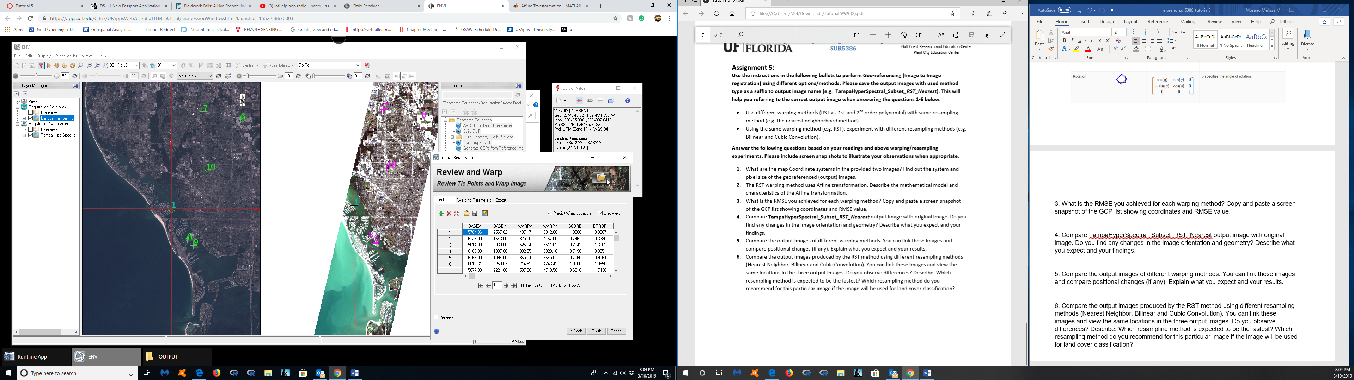

First order polynomial

RMS ERROR- 2.1700

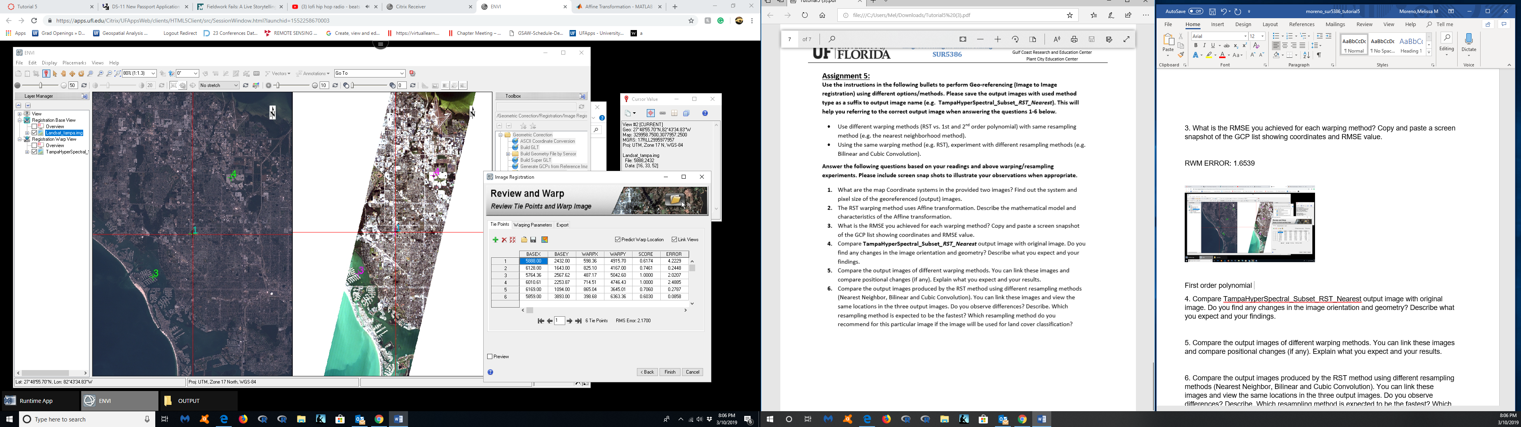

4. Compare TampaHyperSpectral_Subset_RST_Nearest output image with original image. Do you find any changes in the image orientation and geometry? Describe what you expect and your findings.

TampaHyperSpectral_Subset_RST_Nearest

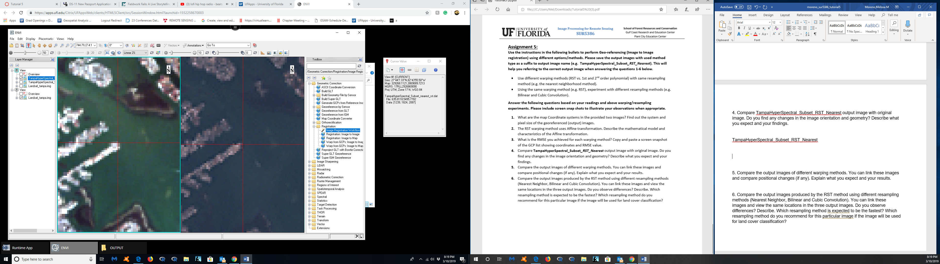

Original

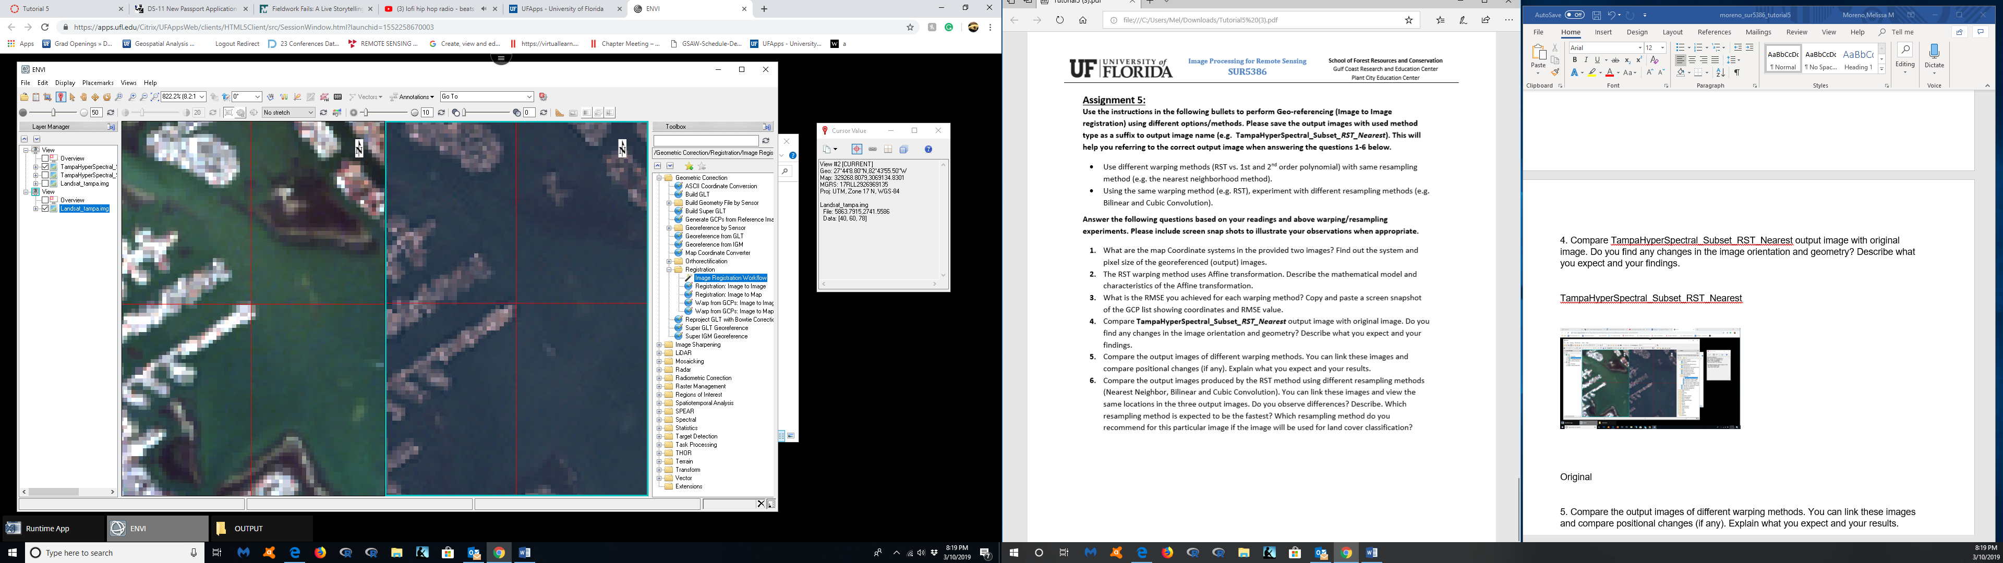

Image orientation seems to be the same. I find that the original image has a slightly higher geo coordinate than does the nearest neighbor image. I expect that the nearest neighbor to be more accurate to the original image. The nearest neighbor is linking the tie points and creating an output image with referenced geo spatial points.

5. Compare the output images of different warping methods. You can link these images and compare positional changes (if any). Explain what you expect and your results.

Warping Method-

RST (left) and Polynomial (right)

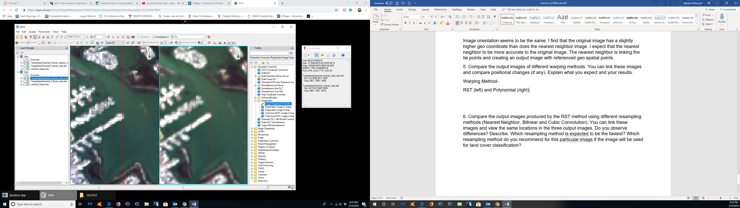

What I expect in my results is for RST to be a fast result, but for polynomial to be more accurate. Polynomial includes an XP interaction term, meaning it is available from the 1rst to the nth degree. For RST, I need three or more GCPS, in this case I had 9, just like the example tutorial.

6. Compare the output images produced by the RST method using different resampling methods (Nearest Neighbor, Bilinear and Cubic Convolution). You can link these images and view the same locations in the three output images. Do you observe differences? Describe. Which resampling method is expected to be the fastest? Which resampling method do you recommend for this particular image if the image will be used for land cover classification?

Nearest Neighbor- Fastest (<https://gisgeography.com/raster-resampling/> ) (left)

Nearest neighbor is a resampling method used in remote sensing. The approach assigns a value to each "corrected" pixel from the nearest "uncorrected" pixel. The advantages of nearest neighbor include simplicity and the ability to preserve original values in the unaltered scene. The disadvantages include noticeable position errors, especially along linear features where the realignment of pixels is obvious. (<https://articles.extension.org/pages/9628/remote-sensing-resampling-methods> )

Bilinear can refer to bilinear filtering or bilinear interpolation. Bilinear filtering is an image smoothing method when the image is displayed larger or smaller than it actually is. Bilinear filtering uses points to perform bilinear interpolation. This is done by interpolating between the four pixels nearest to the point that best represents that pixel (usually in the middle or upper left of the pixel). (<https://articles.extension.org/pages/9628/remote-sensing-resampling-methods> )

Cubic convolution (right) is a method used to determine the gray levels in an image through a weighted average of the 16 closest pixels to the input coordinates. The resulting value is then assigned to the output coordinates. This method generally is considered better than bilinear interpolation, and it does not have the disjointed appearance of nearest neighbor interpolation. Cubic convolution requires about 10 times the computation time required by the nearest neighbor method. (<https://articles.extension.org/pages/9628/remote-sensing-resampling-methods>)

For this particular image I would not recommend cubic convolution, as it would take way too much time to process. I think for this image I would also not choose a bilinear because it displays the image larger or smaller than it actually it. I believe that nearest neighbor would be the best option because it assigns a value to each “correct” pixel from the near “uncorrected” pixel. There could be some errors with this approach but that can be later corrected.

Which resampling method do you recommend for this particular image if the image will be used for land cover classification?

I expect that the cubic convolution method would be the best method for the land cover classification because it will take into account the gray levels of the image and weight the average according to those output coordinates.

